The Woman who is mentoring me works in the Heliophysics department at NASA.

**Monday**

Went to orientation and meet other interns as well as my mentor

She took me round and had me meet other people we would be working with

Gave be the option of two projects

Coding the robot project

Mapping the dark Aurora lights using MATLAB

**Tuesday**

Was a research day

Looked up how to program in LabView and checked out basic information on the Northern Lights

**Heliophysics** is the study of the effects of the Sun on the Solar System; it addresses problems that span a number of existing disciplines – solar and heliospheric physics, and magnetospheric and ionospheric physics for the Earth and other planets.

**Wednesday**

One of the other people I am working with got the materials for the project that was needed

We went through the list checked and he gave me a more in def look into the mechanical part of the project.

**Thursday**

Nothing happened this day spent the day moving into apartment

**Friday**

None one seems to be around in the morning, so I’m taking this time to do a recap of the week and a general view of the project I’m be working on.

Then getting keys

Slight trial coding with the old code error but got the tif image to display

**Project 1 -Talk Machines Mechanisms**

**This project has to do with using a New visual programming language called LabView in order to tell the motors with a vacuum seal environment a correct reset position. The goal is to have a button code in the interface that can correctly reset the motors to what I call the sweet spot. This will enable testing to be a lot easier for them, in terms of accurate testing and the collection of the consistent data.**

**I believe the overall project is the test of the of certain elements in the atmosphere and in space. There is an ion gun that ionizes some an element and shots it into the vacuum seal. Based on the time it takes for the sensor to pick up and the size of the box, it should give to correct answer to which element it is reading. Once all code is done and the test comeback constantly conclusive with appropriate accuracy (from which my mentor will decide) then I believe it will be ready for space.**

**LabView is the programming language I need to learn. At first glance it looks almost as confusing as SML was for but upon further research and tutorial I learned it was a visual type of programming the engineers use. With my background in regular programming languages, this feels like a better to comprehend because I already get the concepts of what each tool is supposed to do. Though I Still haven’t had a chance to try it out yet, from what I have seen I believe I can make at least understand what has been done already. With the help of my mentor she will tell what the results I should be putting in and what I should be getting out.**

**Side not LabView is widely used and in NASA and in industrial setting so, learning this I feel can really boost my overall skills and hiring potential should I need work in the future.**

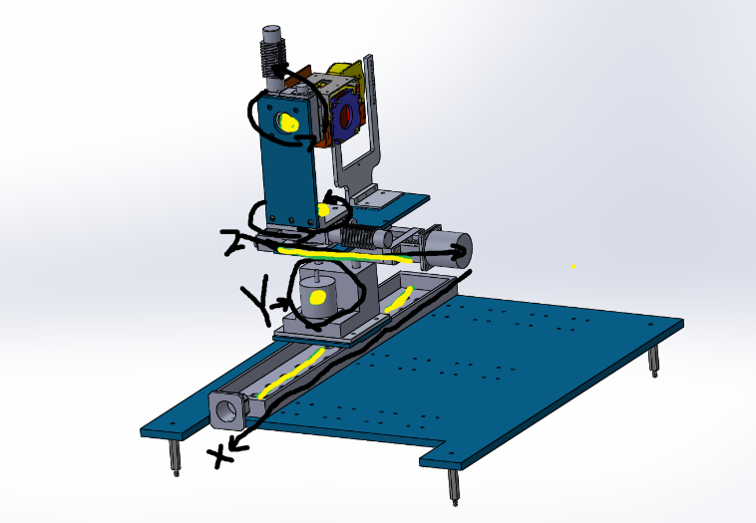

**(Above is a model of the mechanism within the vacuum seal chamber that I will be coding with LabView.)**

**The engineer got new parts and will be within a coupling week constructing it from better parts. Very excited for the part.**

**The overall thought is that this would be similar to working with the scribbler and the raspberry pie from freshmen and the past year when helping out the current freshmen of 2018. If I am correct its finding what commands call each rotator. Then setting in numbers or values to determine the position. After that set up a little function that activates when the bottom is pushed go back to whatever sweet spot they choose.**

**Project 2 - MATLAB Aurora Lights**

**When my mentor went to the polar bear capital of the world she and a group of scientists went to record the sky. The have about hours of footage white peculiar dark spots the seem to randomly be moving about the sky.**

**She wants me to use a MATLAB or Python code in order to map the directions and then after showing her the data and the path way the dark spots are traveling it might be able to give her new information on what the dark spots actually are and how they affect the or are affect overall by the sun. This is important because the Northern Lights have to do with the Sun light and or magnetic field effecting earths magnetic field.**

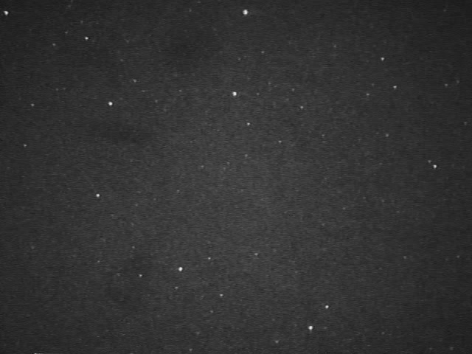

**(few spots in the upper left-hand corner that are darker than the rest)**

**She gave me the option of MATLAB and or Python but I choose MATLAB because Dr. Holiness had my class do a project during class within MATLAB with similar idea or an adjustable idea.**

**One comparing frames of one picture to the original face picture. Similar to the movies where they take a picture of person on the street and then compare to all other pictures in the criminal database. A basic version of that.**

**My though process is that I could reuse the same code in order to highlight and record slightly darker patches in the picture. Since that is technically what the other code is doing. If anything, I thought this would be a good place to start since its not from scratch and its just a little editing and then processing the 8 hours of information.**